CTM GUI
Purpose; the CTM provides information in a number of ways that are not identical to how Samples are accessed in JIRA.

CTM, Tables of 'References'
Purpose: Samples are the core of either Sample Tracking system (in the CTM the term 'References' is used). These tables provide a list of Samples based on certain search criteria. They contain a summary of the current state of each Sample.
Description:
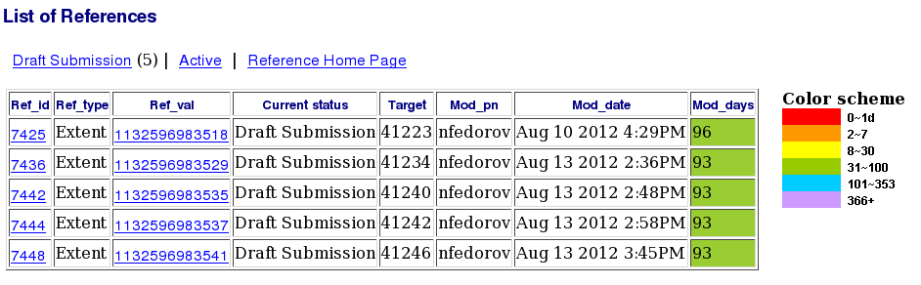Illustration 1: Table of 'References' that are in the Draft Submission 'Queue'
Both illustrations appear in the main area of the Home page.
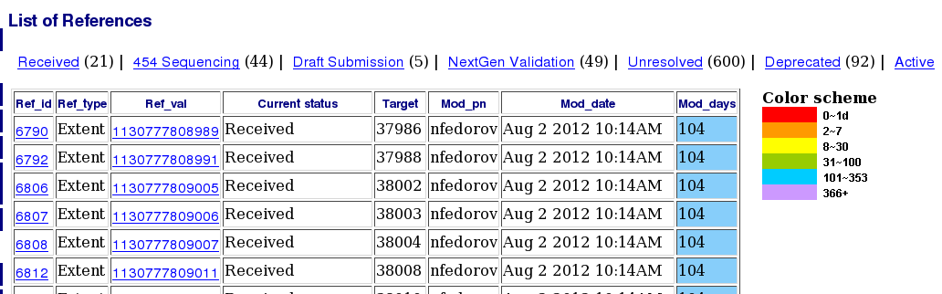Illustration 2: Table of 'References' that are currently 'Active'
Illustration 1 was produced by selecting a single Status, 'Draft Submission', from the list of statuses available on the 'Reference Manager' page.
Illustration 2 was created by following the 'Active' link above the previous table.
- Above the table there is a list of the Statuses that appear in the table with the number of times each appears in brackets.
- Samples can only be selected by Status or Active. The search function just returns a list of ids with no extra information.
- Ref_id and Ref_type are no longer required.
- Ref_val is Extent ID
- Target is BAC ID
- Mod_pn is Assignee
- Mod_date is the date of the last update
- Mod_days is the number of days since the Sample's entry was last modified

CTM, Side-bar
Purpose; the side-bar is used, via drop-down menus, to select specific samples. The samples are grouped by their current status. The side-bar also provides a summary of the number of samples with each status.
Description:
Illustration 3 contains a section of the side-bar. There are headings for each of the statuses that exist in the database, including those that currently contain no samples. Any empty statuses do not have drop-down menus.
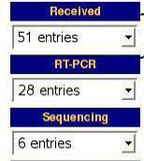Illustration 3: Side-bar

CTM, Tables for 'Tasks'
Purpose; the CTM was created to keep track of the work that needed to be carried out on the Samples, as well as record a record of the work that had taken place. Tasks were used to represent units of work that could be assigned to a particular user. (Specially named statuses were also used when the work did not require lab work).
Description:
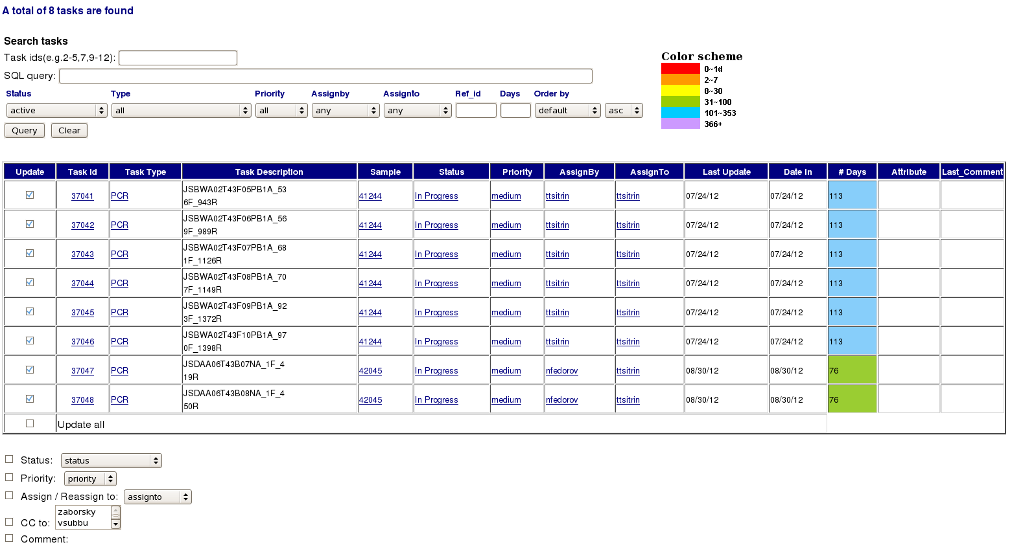Illustration 4: Task Manager
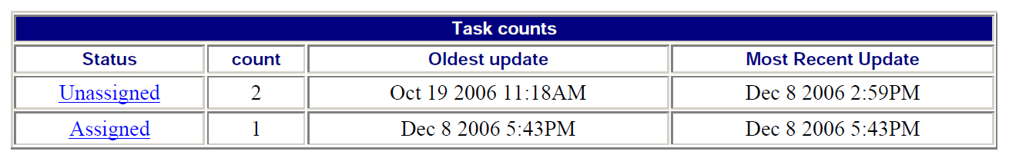Illustration 5: The 'Task counts' table from a Reference's (Sample's) Homepage
Illustration 4 is the result of carrying out a search in the Task Manager section of CTM. Tasks can be selected using a wide range of search methods, unlike 'References'
Illustration 5 is part of the information displayed when a specific 'Reference' is selected.
Summary:
Report | Search terms | Report Content
CTM Navigation Page-Table | Database,  Status | ref_id,  ref_type.  Extent ID (Rer_value),  Status,  BAC ID (target),  Assignee,  Updated,  Days since most recent update
CTM Navigation Page-Table | Database,  Active
CTM Navigation Page-Side bar | Database | Status,  Count { Samples (References) }  GROUPED BY Status
CTM Task Manager | Database  Task ID / Status / Sub-task (Task Type) / Priority / Assigned by / Assignee | Task ID,  Status,  Sub-task (Task Type),  Priority,  Assigned by,  Assignee,  Updated,  Days since most recent update,  Most recent Comment
CTM Task Counts | Ref_id / Extent ID / BAC ID | Task Status,  count { Tasks },  min { Creation Date (Oldest Update) }  max { Updated }  GROUPED BY Task Status

